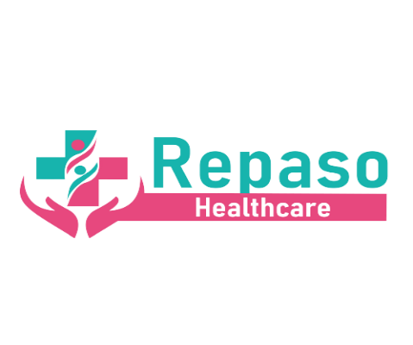

Carbon Reduction Plan (CRP)

Commitment to Achieving Net Zero
Repaso Care Limited is committed to achieving Net Zero greenhouse gas (GHG) emissions by 2050, in line with UK Government legislation and the NHS Net Zero ambition. Our organisation recognises the urgent need to address climate change and is taking active steps to reduce emissions across all areas of our operations.

Baseline Emissions Footprint
As a recently established organisation, our baseline emissions data is currently being compiled. The baseline year will serve as the foundation for monitoring progress and setting interim targets. This section will be updated as soon as the data collection process is finalised.
Baseline Year: 2023
Emissions for Baseline Year (estimated):
- Scope 1 (Direct Emissions): To be measured (e.g., heating and fuel use in facilities).
- Scope 2 (Indirect Emissions from Energy): To be measured (e.g., purchased electricity).
- Scope 3 (Other Indirect Emissions): To be measured (e.g., travel, procurement, waste management).

Current Emissions Reporting
Until the baseline data is finalised, the organisation is implementing interim measures to reduce emissions proactively. Future annual CRP updates will include detailed Scope 1, 2, and 3 emission metrics for each reporting period.
Reporting Period: January 2023 to December 2023
- Scope 1: Data collection in progress.
- Scope 2: Data collection in progress.
- Scope 3: Data collection in progress.

Environmental Management Measures
To reduce our carbon footprint, Repaso Care Limited has implemented and committed to the following initiatives:

1. Energy Efficiency
- Transition to energy-efficient lighting and appliances in all facilities.
- Monitor and reduce energy consumption through the adoption of smart energy meters.
- Switch to renewable energy suppliers for office spaces by 2025.

2. Sustainable Travel
- Encourage the use of virtual consultations and remote working to minimise travel-related emissions.
- Promote public transport, car-sharing schemes, and the use of low-emission vehicles for necessary travel.
- Commit to transitioning to an electric or hybrid vehicle fleet by 2030.

3. Sustainable Procurement
- Work with suppliers who align with sustainability goals, prioritising eco-friendly products and services.
- Include environmental considerations as a criterion in procurement processes.
- Reduce single-use plastics and other non-recyclable materials in the supply chain.

4. Waste Reduction
- Implement robust recycling programmes in all offices and facilities.
- Encourage paperless operations by digitising records and processes where possible.
- Regularly audit waste management practices to identify further reduction opportunities.

5. Staff Engagement and Training
- Train employees on sustainable practices, such as energy conservation and waste reduction.
- Introduce sustainability goals into staff appraisals and organisational culture.
- Provide regular updates on the company’s progress toward Net Zero and how employees can contribute.

Targets
Repaso Care Limited has set the following interim targets to ensure progress toward Net Zero by 2050:
- 2025: Achieve a 25% reduction in Scope 1 and Scope 2 emissions compared to the baseline year.
- 2030: Achieve a 50% reduction in total emissions.
- 2040: Achieve an 80% reduction in total emissions.
- 2050: Achieve Net Zero across all Scope 1, 2, and 3 emissions.

Progress Monitoring
Progress toward these targets will be monitored using the following methods:
- Annual emissions audits, with results published in an updated CRP.
- Quarterly reviews of energy consumption, travel-related emissions, and waste reduction metrics.
- Engagement with third-party environmental consultants to verify progress and ensure compliance with standards.

Governance
The responsibility for implementing and monitoring the Carbon Reduction Plan lies with the Sustainability Lead, who will report progress directly to the board of directors. The Sustainability Lead will also ensure compliance with NHS and government environmental policies.

Future Updates
The Carbon Reduction Plan will be reviewed and updated annually to reflect the following:
- Actual emissions data for Scopes 1, 2, and 3.
- Progress toward interim and long-term Net Zero targets.
- New initiatives or improvements in environmental management measures.

Contact Information
For further information or inquiries about our Carbon Reduction Plan or environmental commitments, please contact us at:
Email: info@repasohealthcare.co.uk

Declaration
Repaso Care Limited is committed to reducing emissions and achieving Net Zero by 2050. This CRP reflects our current efforts, planned initiatives, and commitment to sustainability.
Director Approval:
Name: Reginald Adjei
Position: Director
Date: 01/01/2025

